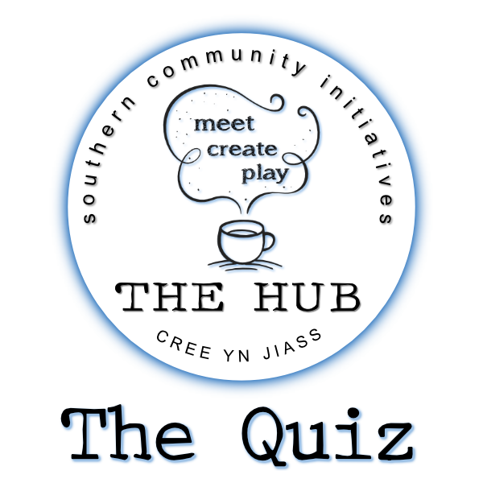

Q1 | What is the most common colour of toilet paper in France?
ANSWER
Q2 | Who entered a contest to find his own look-alike and came 3rd?
ANSWER
Q3 | French artist Aquabouse paints cows with what material?
ANSWER
Q4 | In 1978 an Iowa judge dismissed a drink driving charge for what obscure reason?
ANSWER
Q5 | In which country are there six villages called Silly, 12 called Billy, and two called Pratt?
ANSWER
Q6 | Native to the Caribbean, what sort of animal is the mountain chicken?
ANSWER
Q7 | The UK's Dyslexia Research Trust is based in which British city?
ANSWER
Q8 | What nickname was given to Rembrandt's The Night Watch after being over-restored in the 1940s?
ANSWER
Q9 | True or false: You can sneeze in your sleep
ANSWER
Q10 | Who invented the word vomit?
ANSWER
Q11 | Which European country has 158 verses to its national anthem?
ANSWER
Q12 | If you dug a hole through the centre of the earth starting from Wellington in New Zealand, which European country would you end up in?
ANSWER
Q13 | Which country has the most tornadoes by area?
ANSWER
Q14 | The leader of which country has his face on all the joghurt pots, has named the month January after himself and banned ballet.
ANSWER
Q15 | What is Scooby Doo’s full name?
ANSWER
Q16 | What is the collective noun for a group of unicorns?
ANSWER
Q17 | Where was the fortune cookie invented?
ANSWER
Q18 | What is the cross between a donkey and a zebra known as?
ANSWER
Q19 | Henry VIII introduced which tax in England in 1535?
ANSWER
Q20 | What is the correct term for a question mark immediately followed by an exclamation mark?
ANSWER
Q21 | The average person does what thirteen times a day?
ANSWER
Q22 | Coprastastaphobia is the fear of what?
ANSWER
Q23 | What were the first ice hockey pucks made out of?
ANSWER
Q24 | It's illegal in Texas to put what on your neighbour’s Cow?
ANSWER
Q25 | Which bird is nicknamed The Laughing Jackass?
ANSWER
Q26 | Vietnam claimed independence from which country in 1945?
ANSWER
Q27 | What is the capital city of Ethiopia
ANSWER
Q28 | Guess the year; Fleetwood Mac’s album ‘Rumours’ was released, Red Rum won the Grand National for the third time and Queen Elizabeth II celebrated her Silver Jubilee.
ANSWER
Q29 | Complete the lyrics; Tonight, I’m gonna have myself a real good time
ANSWER
Q30 | What is the highest points total in a season ever achieved by a team in the English Premier League?
ANSWER
Q31 | Holden Caulfield, an icon for teenage angst and rebellion, is a fictional character in which American literary classic?
ANSWER
Q32 | What do the two initials stand for in C. S. Lewis?
ANSWER
Q33 | Who played Mrs Robinson in The Graduate?
ANSWER
Q34 | In the UK we refer to them as baked beans, but what type of bean are they?
ANSWER
Q35 | Poppy Honey Rosie, Daisy Boo Pamela, Petal Blossom Rainbow, Buddy Bear Maurice, and River Rocket Blue Dallas, are the names of the children from which celebrity couple?
ANSWER
Q36 | Who is the only woman to ever be selected as Speaker of the House of Commons?
ANSWER
Q37 | Name the TV show; At the venue this show is set in ‘everybody knows your name, and they’re always glad you came’.
ANSWER
Q38 | Vanilla is a member of which plant family?
ANSWER
Q39 | What is the body part the axilla also known as?
ANSWER
Q40 | Which artist created "A Bigger Splash"
ANSWER
Q41 | Where would you find Bran Castle
ANSWER
Q42 | Which sporting event first took place on 29 March 1981?
ANSWER
.

.

.

.

there’s a picture round down here…

.

.

.

.

.

.

keep going…
PICTURE ROUND!

Frequent visitors
Can you name the celebrity from these cropped pictures?

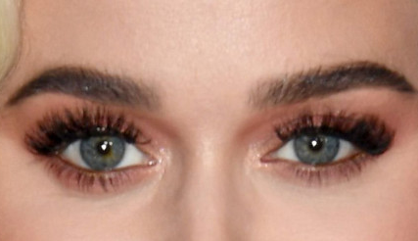 | 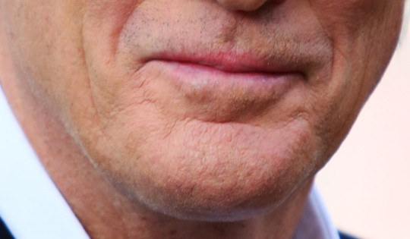
 | 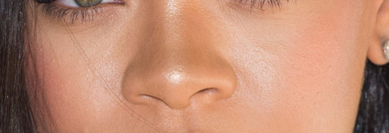
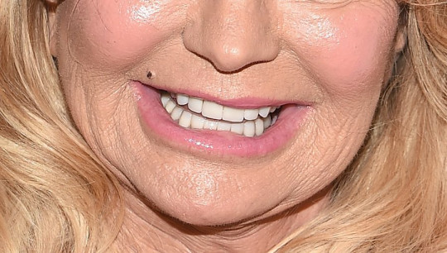 | 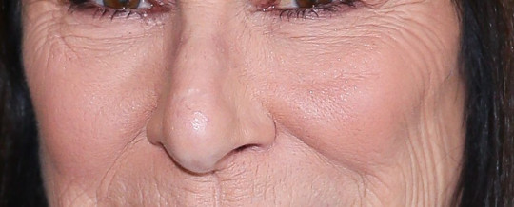
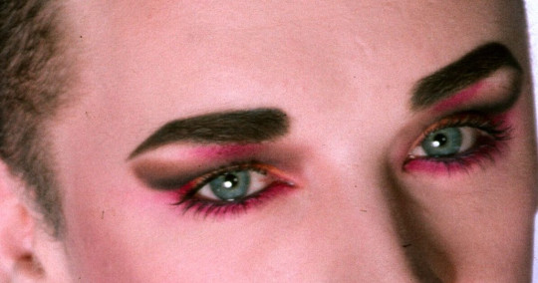 | 