Q1 | What colour is found on 75% of the world’s flags?
ANSWER | Red
Q2 | If you were to watch the Marvel Cinematic Universe films in chronological order, which would come first?
ANSWER | Captain America: The First Avenger (2011) – it takes place during WWII
Q3 | What is the name of the evil headteacher in Matilda?
ANSWER | Miss Trunchbull
Q4 | What year was Irn Bru invented?
ANSWER | 1901
Q5 | What do you call a group of rattlesnakes?
ANSWER | Rhumba
Q6 | What year did Elvis die?
ANSWER | 1977
Q7 | In which part of your body would you find the cruciate ligament?
ANSWER | Knee
Q8 | Which band overtook Michael Jackson's Thriller as the best-selling album of all time after Recording Industry Association of America recalculated sales in 2018?
ANSWER | The Eagles
Q9 | Which British Prime Minister was assassinated in 1812?
ANSWER | Spencer Perceval
Q10 | How many films have Al Pacino and Robert De Niro made together?
ANSWER | Four
Q11 | Which planet has the most moons?
ANSWER | Saturn
Q12 | Who was the first Black person to win an Oscar?
ANSWER | Hattie McDaniel in Gone With The Wind
Q13 | Which cocktail is made with whisky, sweet vermouth and bitters?
ANSWER | Manhattan
Q14 | What is the murder weapon in the erotic thriller, Basic Instinct?
ANSWER | Ice pick
Q15 | In what year was the first episode of Eastenders broadcast on TV?
ANSWER | 1985
Q16 | Which boyband did Girls Aloud beat in the final of Popstars: The Rivals in 2002?
ANSWER | One True Voice
Q17 | What was Beyoncé’s first solo album called?
ANSWER | Dangerously in Love
Q18 | What is the tallest building in the world?
ANSWER | Burj Khalifa, Dubai
Q19 | Which animal kills the most humans?
ANSWER | Mosquito
Q20 | What is the symbol for element of gold?
ANSWER | Au
Q21 | Which is the deepest ocean?
ANSWER | Pacific Ocean
Q22 | hairdryer, stapler and neon lighting were all invented in which country?
ANSWER | France
Q23 | Which star wrote the autobiography Me in 2019?
ANSWER | Elton John
Q24 | Where does the epic battle take place in Lord of the Rings' Two Towers?
ANSWER | Helm's Deep
Q25 | In which century did Leonardo da Vinci paint The Last Supper?
ANSWER | 15th century
Q26 | How many teeth does an adult human have?
ANSWER | 32
Q27 | How many shillings in a pound?
ANSWER | 20
Q28 | Which kids’ TV show gave Britney Spears, Justin Timberlake and Christina Aguilera their big break?
ANSWER | Mickey Mouse Club
Q29 | Who wrote The Catcher In The Rye?
ANSWER | JD Salinger
Q30 | Alektorophobia is the fear of what?
ANSWER | Chickens
Q31 | Aduki, borlotti and cannellini are types of what?
ANSWER | Beans
Q32 | Which bird can fly backwards?
ANSWER | Hummingbird
Q33 | Who said this famous quote: ‘If you can’t handle me at my worst, then you sure as hell don’t deserve me at my best'?
ANSWER | Marilyn Monroe
Q34 | Which American is the most decorated Olympian of all time?
ANSWER | Michael Phelps
Q35 | Who created the famous sculpture 'The Thinker'?
ANSWER | Auguste Rodin
Q36 | What was the most downloaded app of 2020?
ANSWER | TikTok
Q37 | Which Beatle crossed Abbey Road behind John Lennon?
ANSWER | Ringo Starr
Q38 | Which year was the Premier League founded??
ANSWER | 1992
Q39 | What is Rihanna's real name?
ANSWER | Robyn Rihanna Fenty
Q40 | What is the northernmost capital city in the world?
ANSWER | Reykjavik, Iceland
Q41 | Z and which other letter are worth the most in Scrabble?
ANSWER | Q
Q42 | How long was Kim Kardashian's marriage to Kris Humphries?
ANSWER | 72 days
.

.

.

.

there’s a picture round down here…

.

.

.

.

.

.

.

.

.

.

keep going…

PICTURE ROUND!

FILM POSTERS
Can you name these famous film classics?

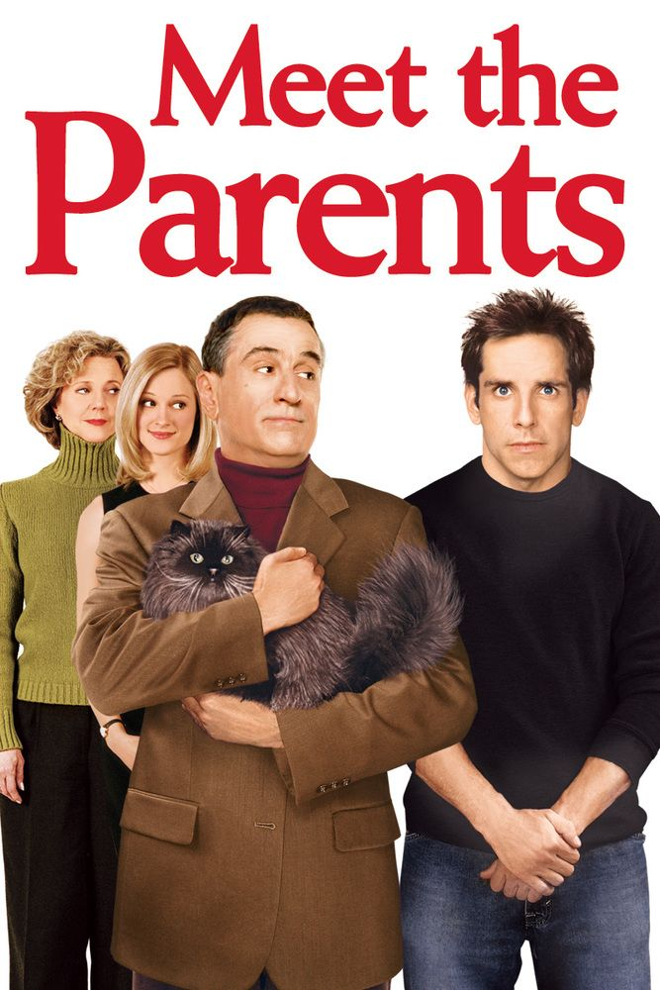 | 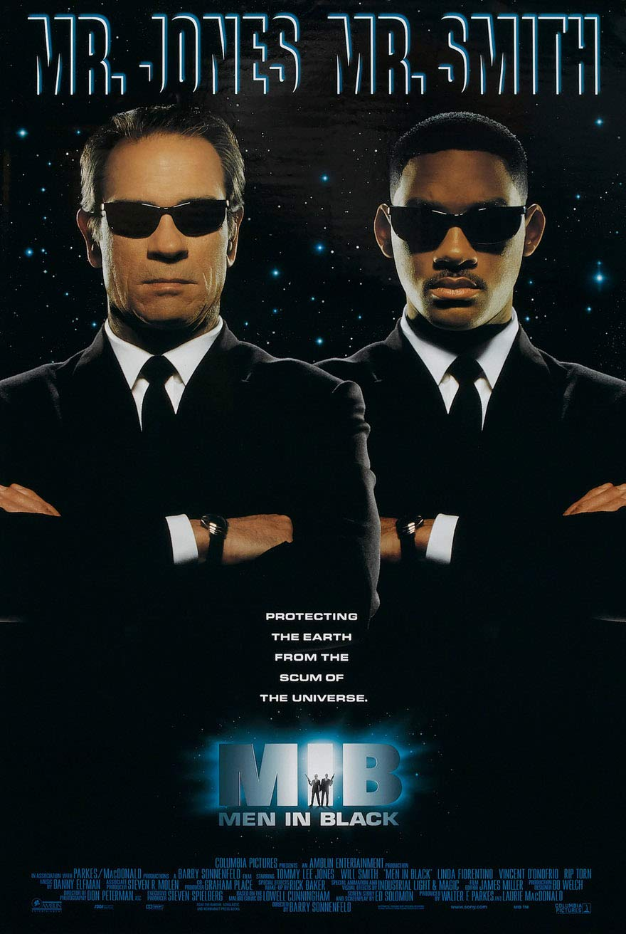 | 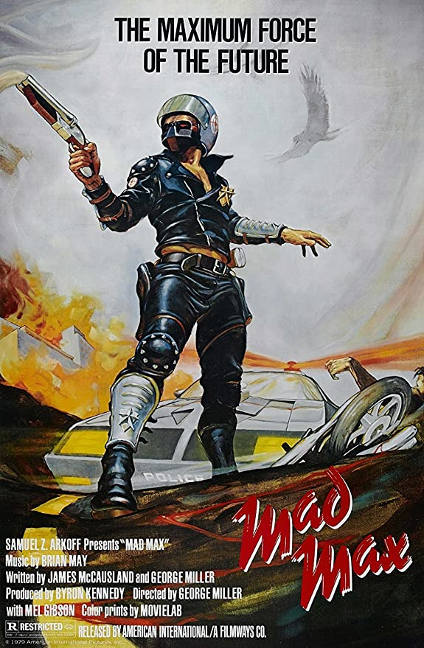 | 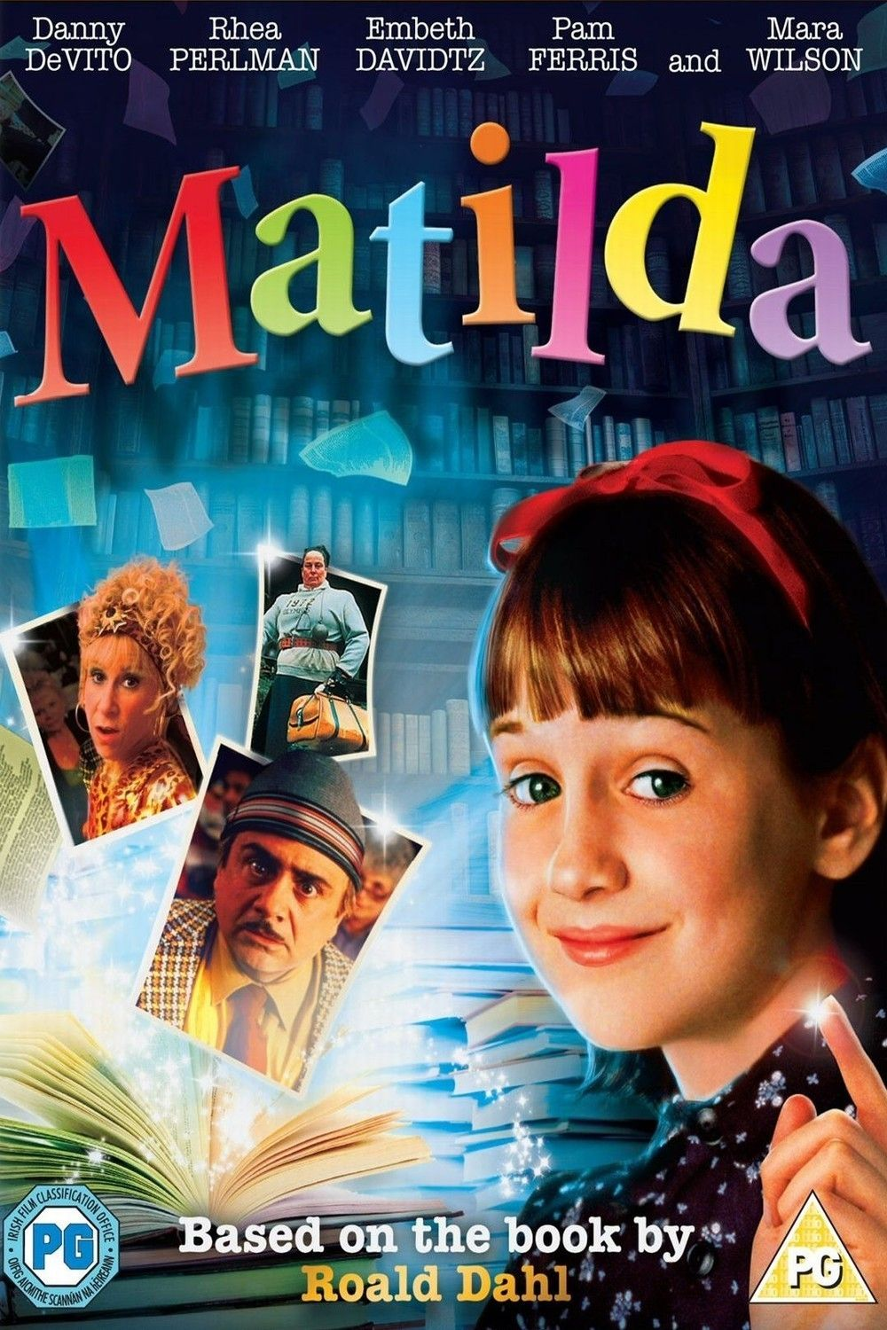
MEET THE PARENTS | MEN IN BLACK | MAD MAX | MATILDA
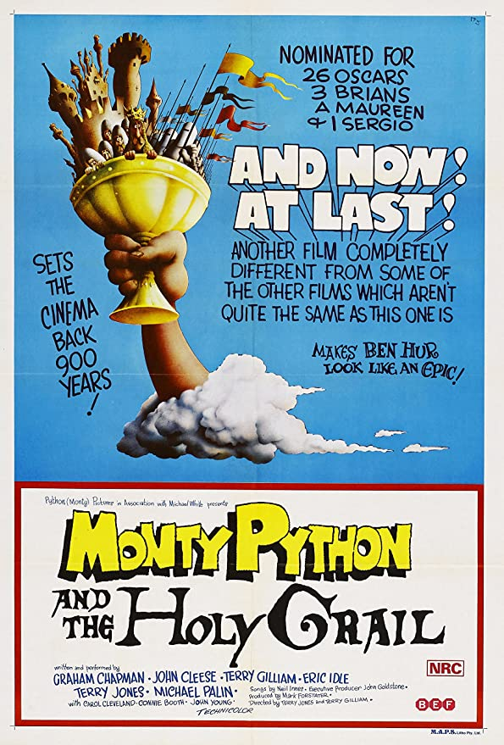 | 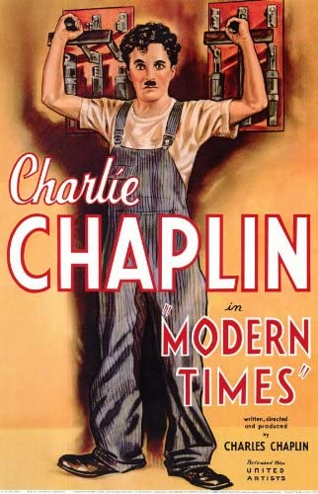 | 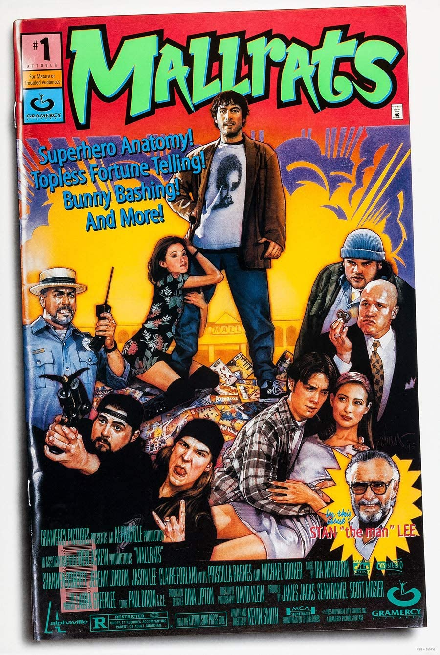
MONTY PYTHON AND THE HOLY GRAIL | MODERN TIMES | MALLRATES | MEAN GIRLS

