Q1 | What colour is found on 75% of the world’s flags?
ANSWER
Q2 | If you were to watch the Marvel Cinematic Universe films in chronological order, which would come first?
ANSWER
Q3 | What is the name of the evil headteacher in Matilda?
ANSWER
Q4 | What year was Irn Bru invented?
ANSWER
Q5 | What do you call a group of rattlesnakes?
ANSWER
Q6 | What year did Elvis die?
ANSWER
Q7 | In which part of your body would you find the cruciate ligament?
ANSWER
Q8 | Which band overtook Michael Jackson's Thriller as the best-selling album of all time after Recording Industry Association of America recalculated sales in 2018?
ANSWER
Q9 | Which British Prime Minister was assassinated in 1812?
ANSWER
Q10 | How many films have Al Pacino and Robert De Niro made together?
ANSWER
Q11 | Which planet has the most moons?
ANSWER
Q12 | Who was the first Black person to win an Oscar?
ANSWER
Q13 | Which cocktail is made with whisky, sweet vermouth and bitters?
ANSWER
Q14 | What is the murder weapon in the erotic thriller, Basic Instinct?
ANSWER
Q15 | In what year was the first episode of Eastenders broadcast on TV?
ANSWER
Q16 | Which boyband did Girls Aloud beat in the final of Popstars: The Rivals in 2002?
ANSWER
Q17 | What was Beyoncé’s first solo album called?
ANSWER
Q18 | What is the tallest building in the world?
ANSWER
Q19 | Which animal kills the most humans?
ANSWER
Q20 | What is the symbol for element of gold?
ANSWER
Q21 | Which is the deepest ocean?
ANSWER
Q22 | hairdryer, stapler and neon lighting were all invented in which country?
ANSWER
Q23 | Which star wrote the autobiography Me in 2019?
ANSWER
Q24 | Where does the epic battle take place in Lord of the Rings' Two Towers?
ANSWER
Q25 | In which century did Leonardo da Vinci paint The Last Supper?
ANSWER
Q26 | How many teeth does an adult human have?
ANSWER
Q27 | How many shillings in a pound?
ANSWER
Q28 | Which kids’ TV show gave Britney Spears, Justin Timberlake and Christina Aguilera their big break?
ANSWER
Q29 | Who wrote The Catcher In The Rye?
ANSWER
Q30 | Alektorophobia is the fear of what?
ANSWER
Q31 | Aduki, borlotti and cannellini are types of what?
ANSWER
Q32 | Which bird can fly backwards?
ANSWER
Q33 | Who said this famous quote: ‘If you can’t handle me at my worst, then you sure as hell don’t deserve me at my best'?
ANSWER
Q34 | Which American is the most decorated Olympian of all time?
ANSWER
Q35 | Who created the famous sculpture 'The Thinker'?
ANSWER
Q36 | What was the most downloaded app of 2020?
ANSWER
Q37 | Which Beatle crossed Abbey Road behind John Lennon?
ANSWER
Q38 | Which year was the Premier League founded??
ANSWER
Q39 | What is Rihanna's real name?
ANSWER
Q40 | What is the northernmost capital city in the world?
ANSWER
Q41 | Z and which other letter are worth the most in Scrabble?
ANSWER
Q42 | How long was Kim Kardashian's marriage to Kris Humphries?
ANSWER
.

.

.

.

there’s a picture round down here…

.

.

.

.

.

.

.

.

.

.

keep going…

PICTURE ROUND!

FILM POSTERS
Can you name these famous film classics?

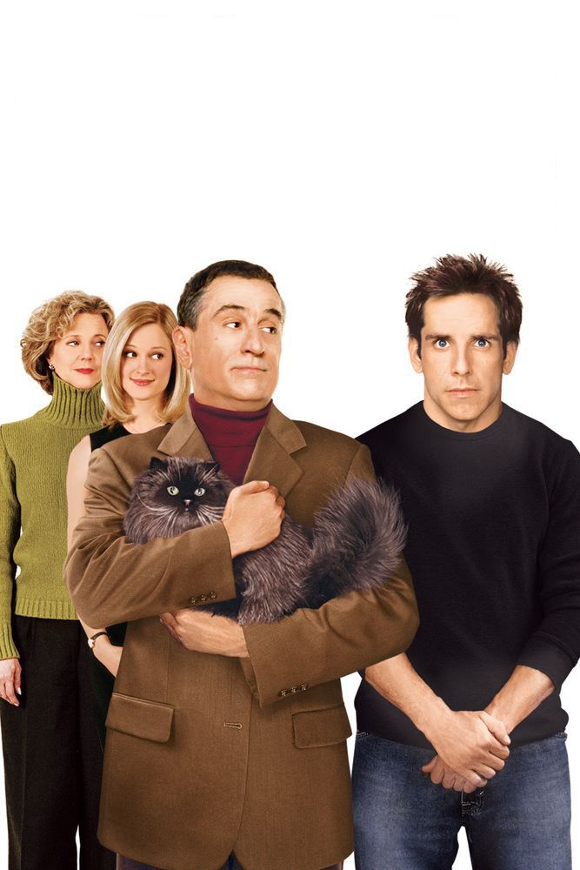 | 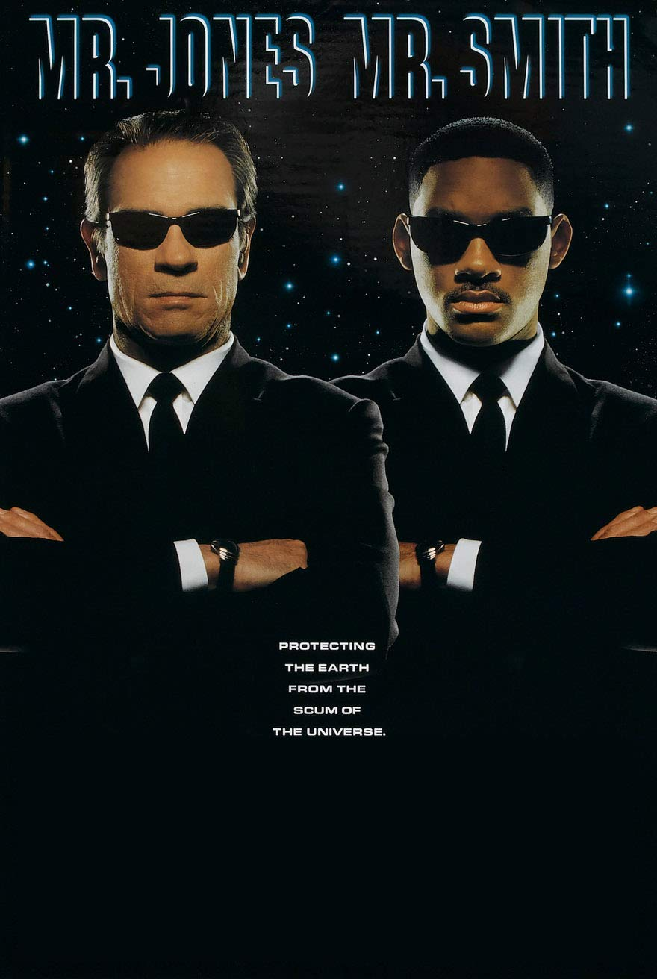 | 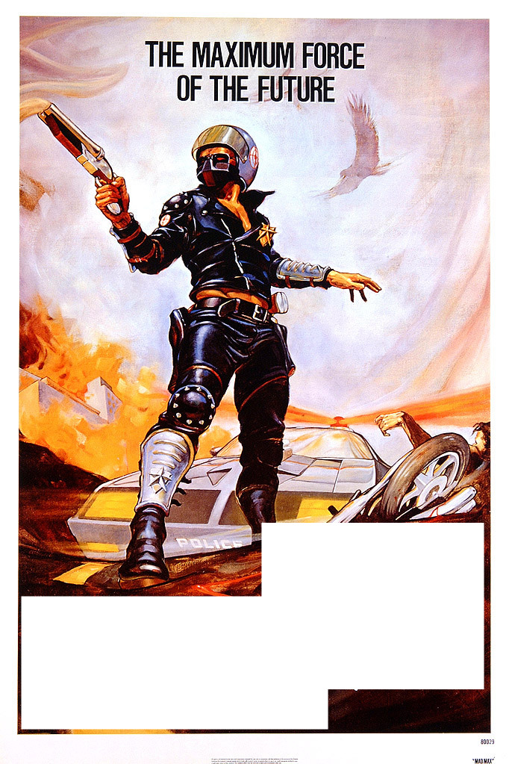 | 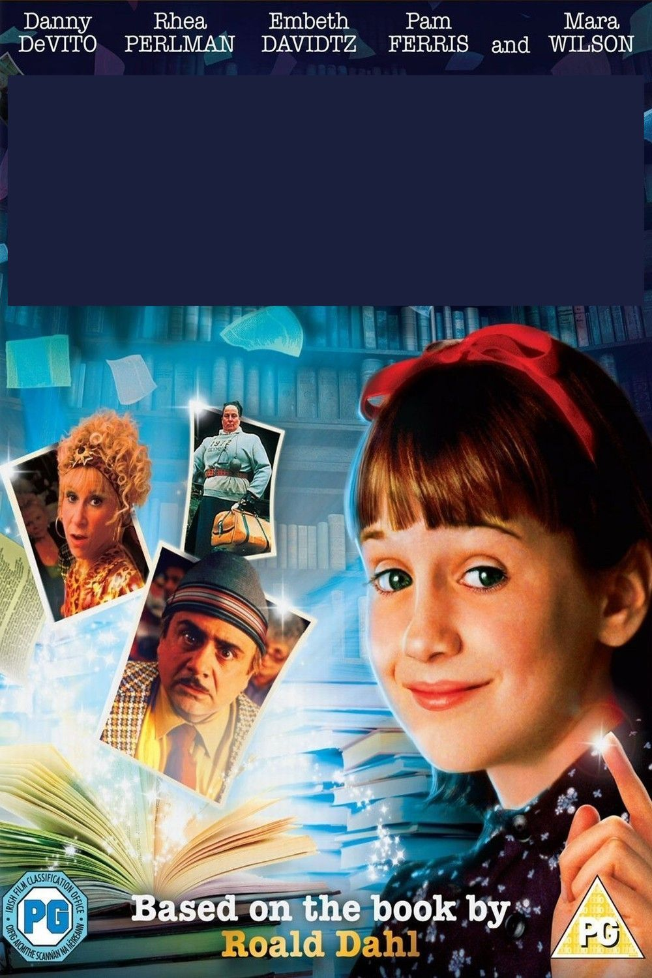
ANSWER | ANSWER | ANSWER | ANSWER
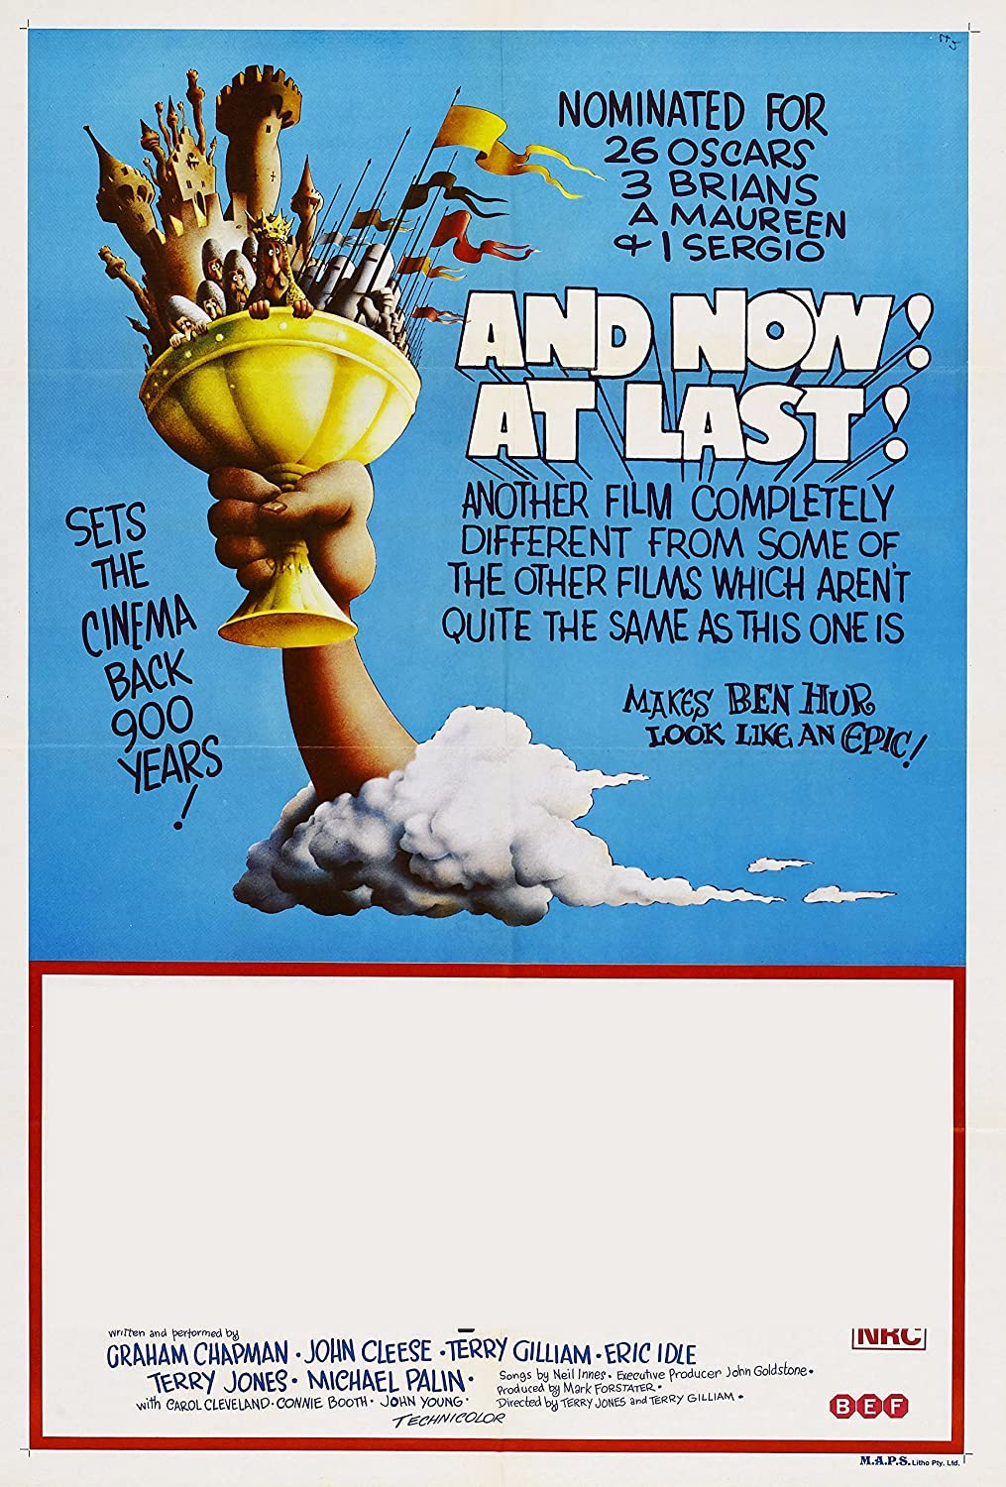 | 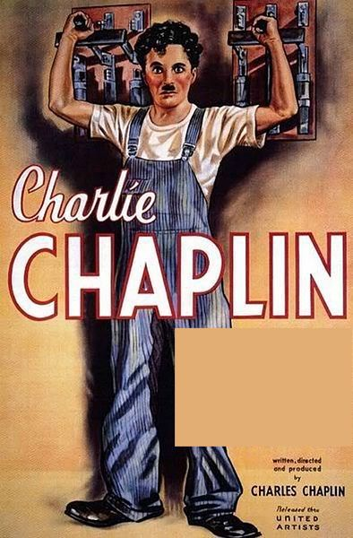 | 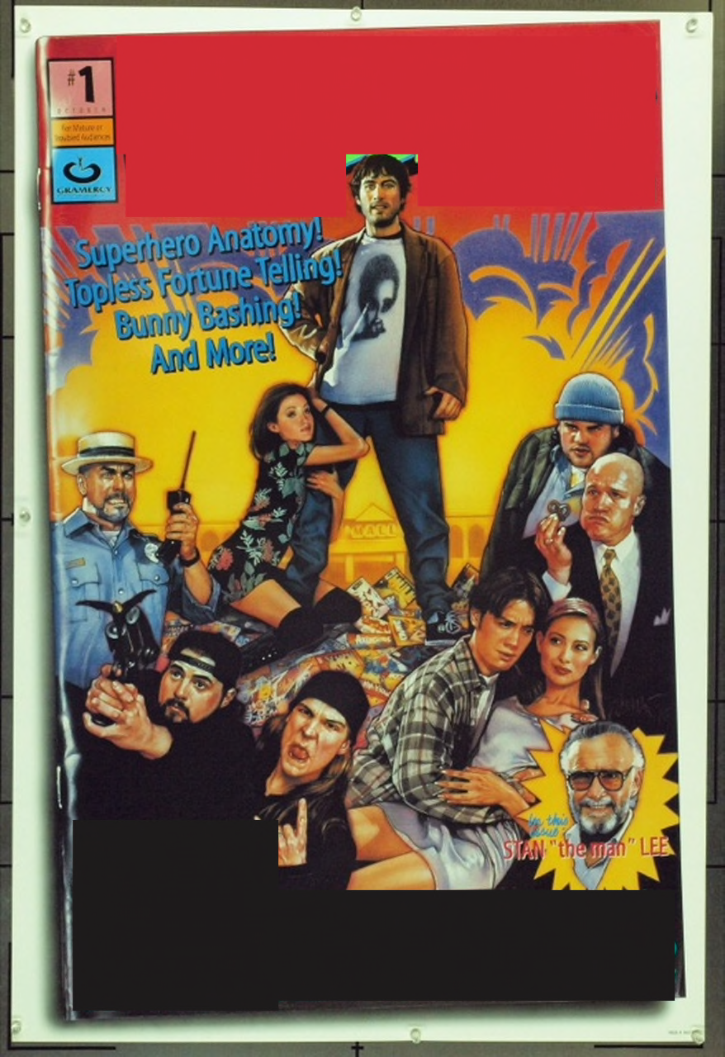
ANSWER | ANSWER | ANSWER | ANSWER

