Q1 | What is the most common colour of toilet paper in France?
ANSWER | Pink
Q2 | Who entered a contest to find his own look-alike and came 3rd?
ANSWER | Charlie Chaplin
Q3 | French artist Aquabouse paints cows with what material?
ANSWER | Cow dung
Q4 | In 1978 an Iowa judge dismissed a drink driving charge for what obscure reason?
ANSWER | Too drunk to sample
Q5 | In which country are there six villages called Silly, 12 called Billy, and two called Pratt?
ANSWER | France
Q6 | Native to the Caribbean, what sort of animal is the mountain chicken?
ANSWER | Frog
Q7 | The UK's Dyslexia Research Trust is based in which British city?
ANSWER | Reading
Q8 | What nickname was given to Rembrandt's The Night Watch after being over-restored in the 1940s?
ANSWER | The Day Watch
Q9 | True or false: You can sneeze in your sleep
ANSWER | FALSE
Q10 | Who invented the word vomit?
ANSWER | William Shakespeare
Q11 | Which European country has 158 verses to its national anthem?
ANSWER | Greece
Q12 | If you dug a hole through the centre of the earth starting from Wellington in New Zealand, which European country would you end up in?
ANSWER | Spain
Q13 | Which country has the most tornadoes by area?
ANSWER | England
Q14 | The leader of which country has his face on all the joghurt pots, has named the month January after himself and banned ballet.
ANSWER | Turkmenistan
Q15 | What is Scooby Doo’s full name?
ANSWER | Scoobert Doo
Q16 | What is the collective noun for a group of unicorns?
ANSWER | A blessing
Q17 | Where was the fortune cookie invented?
ANSWER | San Francisco
Q18 | What is the cross between a donkey and a zebra known as?
ANSWER | Zeedonk
Q19 | Henry VIII introduced which tax in England in 1535?
ANSWER | A beard tax
Q20 | What is the correct term for a question mark immediately followed by an exclamation mark?
ANSWER | Interrobang
Q21 | The average person does what thirteen times a day?
ANSWER | Laughs
Q22 | Coprastastaphobia is the fear of what?
ANSWER | Constipation
Q23 | What were the first ice hockey pucks made out of?
ANSWER | Frozen cow dung
Q24 | It's illegal in Texas to put what on your neighbour’s Cow?
ANSWER | Graffiti
Q25 | Which bird is nicknamed The Laughing Jackass?
ANSWER | Kookaburra
Q26 | Vietnam claimed independence from which country in 1945?
ANSWER | France
Q27 | What is the capital city of Ethiopia
ANSWER | Addis Ababa
Q28 | Guess the year; Fleetwood Mac’s album ‘Rumours’ was released, Red Rum won the Grand National for the third time and Queen Elizabeth II celebrated her Silver Jubilee.
ANSWER | 1977
Q29 | Complete the lyrics; Tonight, I’m gonna have myself a real good time
ANSWER | I feel alive and the world I’ll turn it inside out, yeah
Q30 | What is the highest points total in a season ever achieved by a team in the English Premier League?
ANSWER | 100
Q31 | Holden Caulfield, an icon for teenage angst and rebellion, is a fictional character in which American literary classic?
ANSWER | The Catcher in the Rye by JD Salinger
Q32 | What do the two initials stand for in C. S. Lewis?
ANSWER | Clive Staples
Q33 | Who played Mrs Robinson in The Graduate?
ANSWER | Anne Bancroft
Q34 | In the UK we refer to them as baked beans, but what type of bean are they?
ANSWER | Haricot
Q35 | Poppy Honey Rosie, Daisy Boo Pamela, Petal Blossom Rainbow, Buddy Bear Maurice, and River Rocket Blue Dallas, are the names of the children from which celebrity couple?
ANSWER | Jamie and Jools Oliver
Q36 | Who is the only woman to ever be selected as Speaker of the House of Commons?
ANSWER | Betty Boothroyd
Q37 | Name the TV show; At the venue this show is set in ‘everybody knows your name, and they’re always glad you came’.
ANSWER | Cheers
Q38 | Vanilla is a member of which plant family?
ANSWER | Orchid
Q39 | What is the body part the axilla also known as?
ANSWER | The armpit
Q40 | Which artist created "A Bigger Splash"
ANSWER | David Hockney
Q41 | Where would you find Bran Castle
ANSWER | Transylvania, Romania
Q42 | Which sporting event first took place on 29 March 1981?
ANSWER | The London Marathon
.

.

.

.

there’s a picture round down here…

.

.

.

.

.

keep going…
PICTURE ROUND!

Frequent visitors
Can you name the celebrity from these cropped pictures?

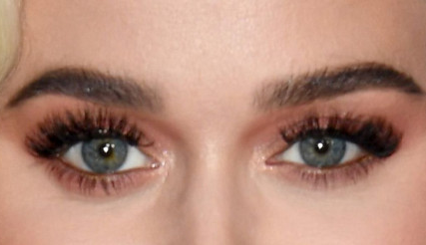 | 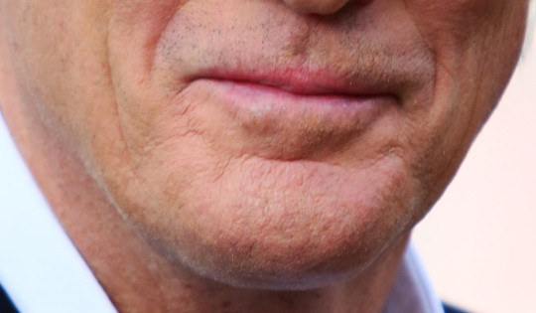
KATY PERRY | RICHARD GERE
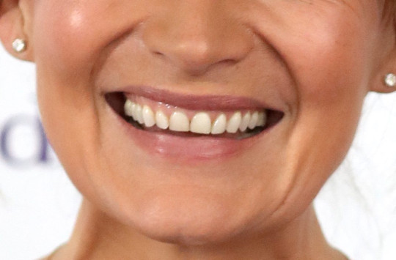 | 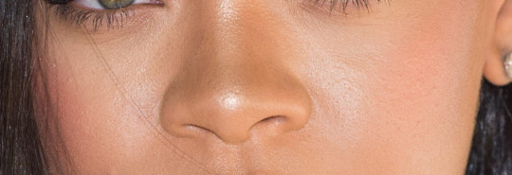
LORRAINE KELLY | RHIANNA
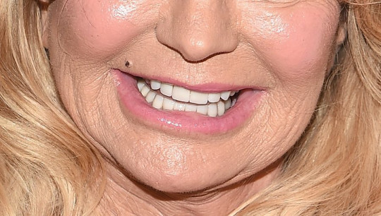 | 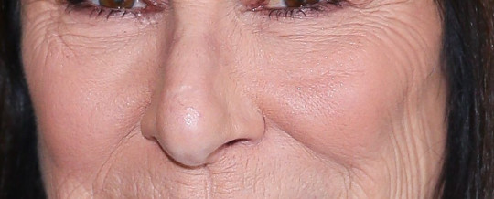
GOLDIE HAWN | ANJELICA HUSTON
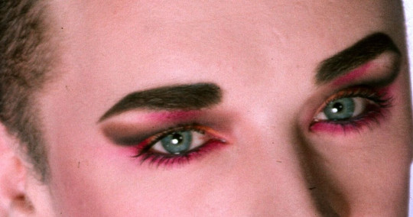 | 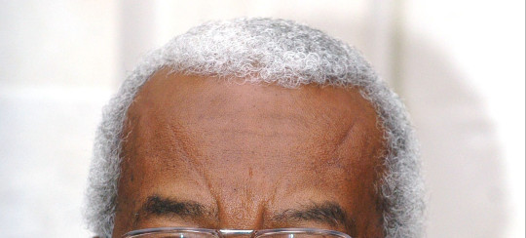
BOY GEORGE | TREVOR McDONALD

